ECE 684 Natural Language Processing – Assignment 3
Nruta Choudhari

Assumptions of the Noisy Channel Model:
- Single Error Per Word: It is assumed that each word contains at most one error, meaning all errors are within an edit distance of one.
- Exclusion of Transpositions: The model does not account for transposition errors, focusing solely on deletions, insertions, and substitutions.
- Vocabulary Limitations: The vocabulary is restricted to the unigram frequency corpus provided by Peter Norvig. Words not included in this corpus are considered invalid.

Testing the code:
After building the code, I used two sets of inputs, and the outputs are as follows:
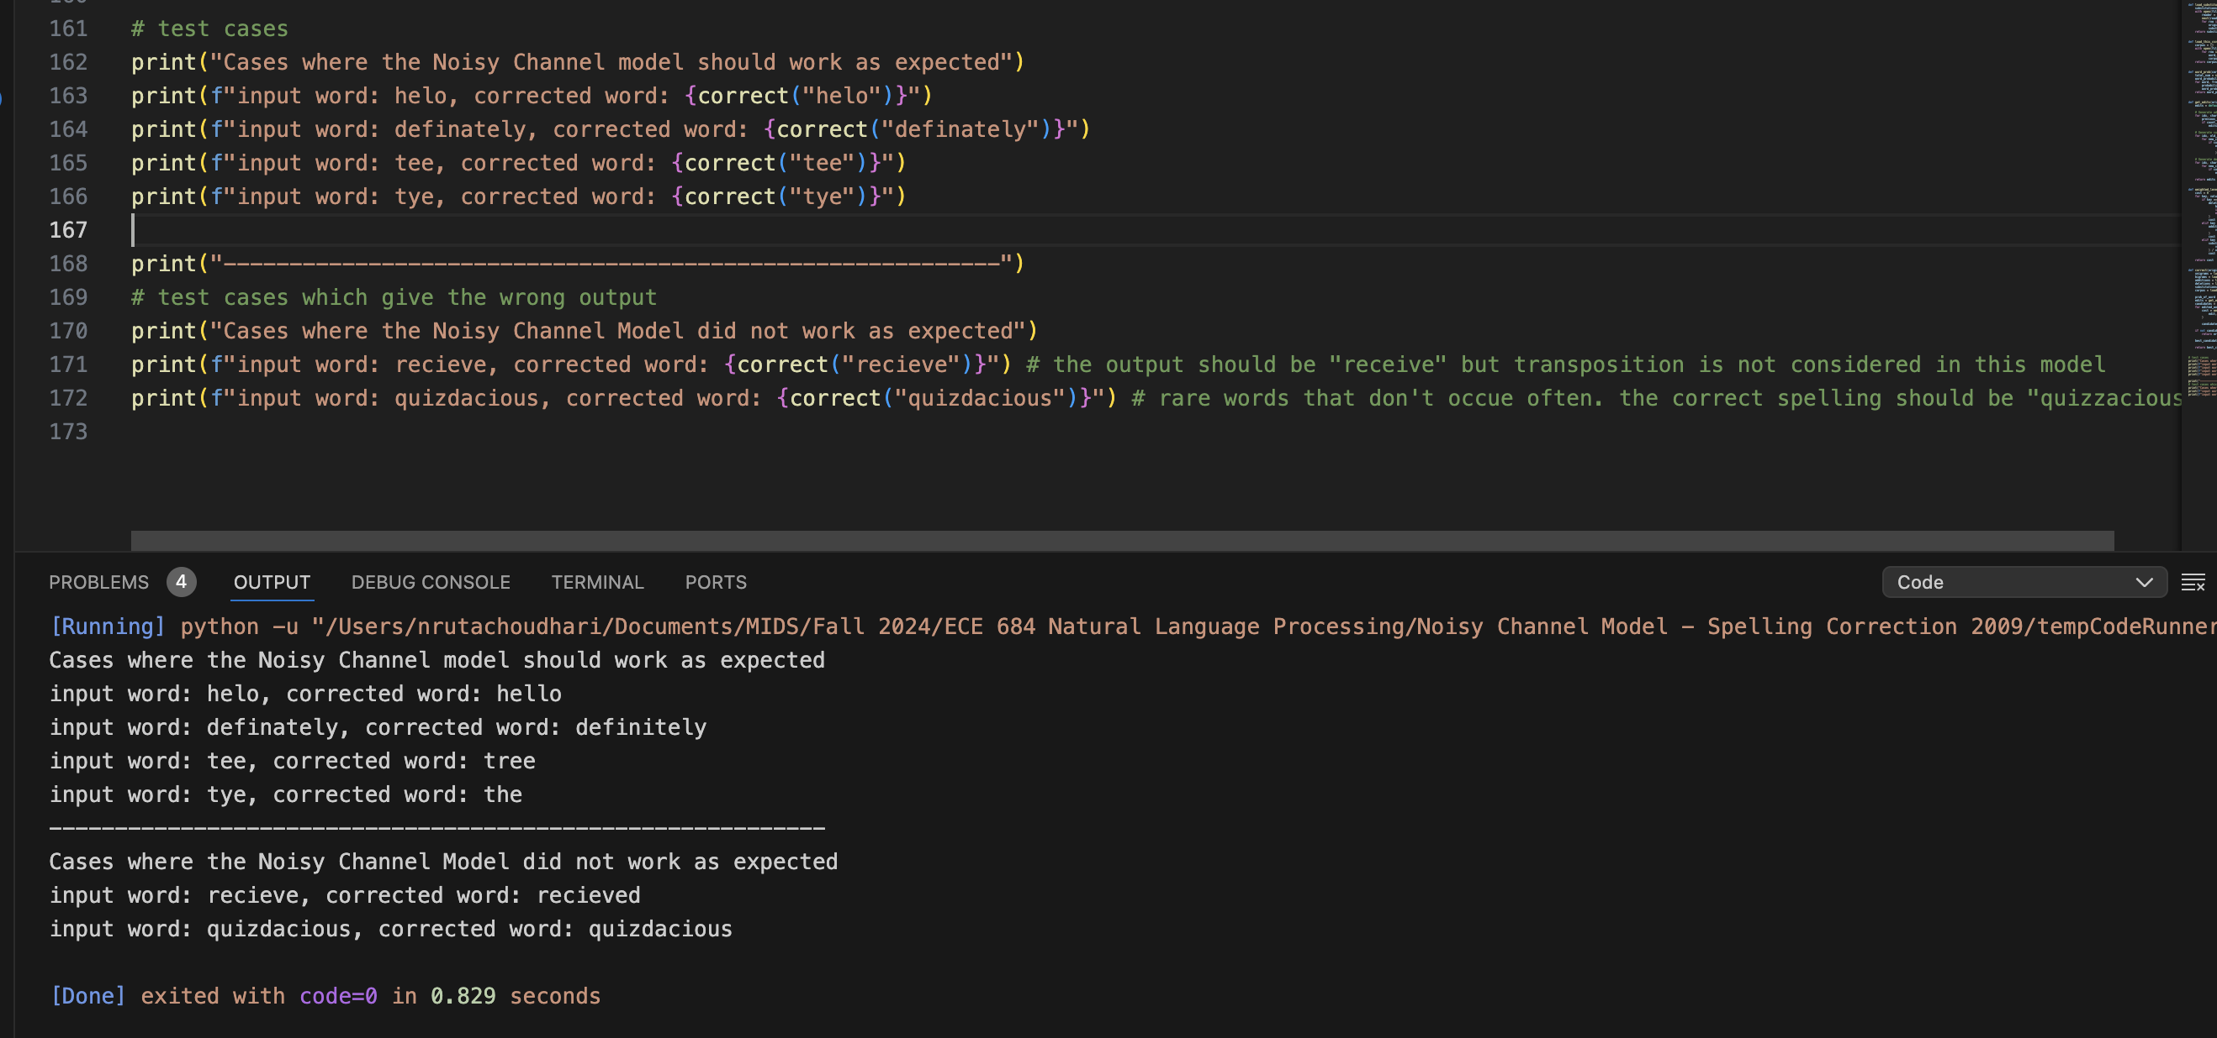
As shown in the screenshot, the output is as expected for the words where there is a substitution, addition or deletion of letters.
However, the model fails when there are cases added where there are transpositions and where the word is rare. In those cases, the output is the same as the misspelled word.

